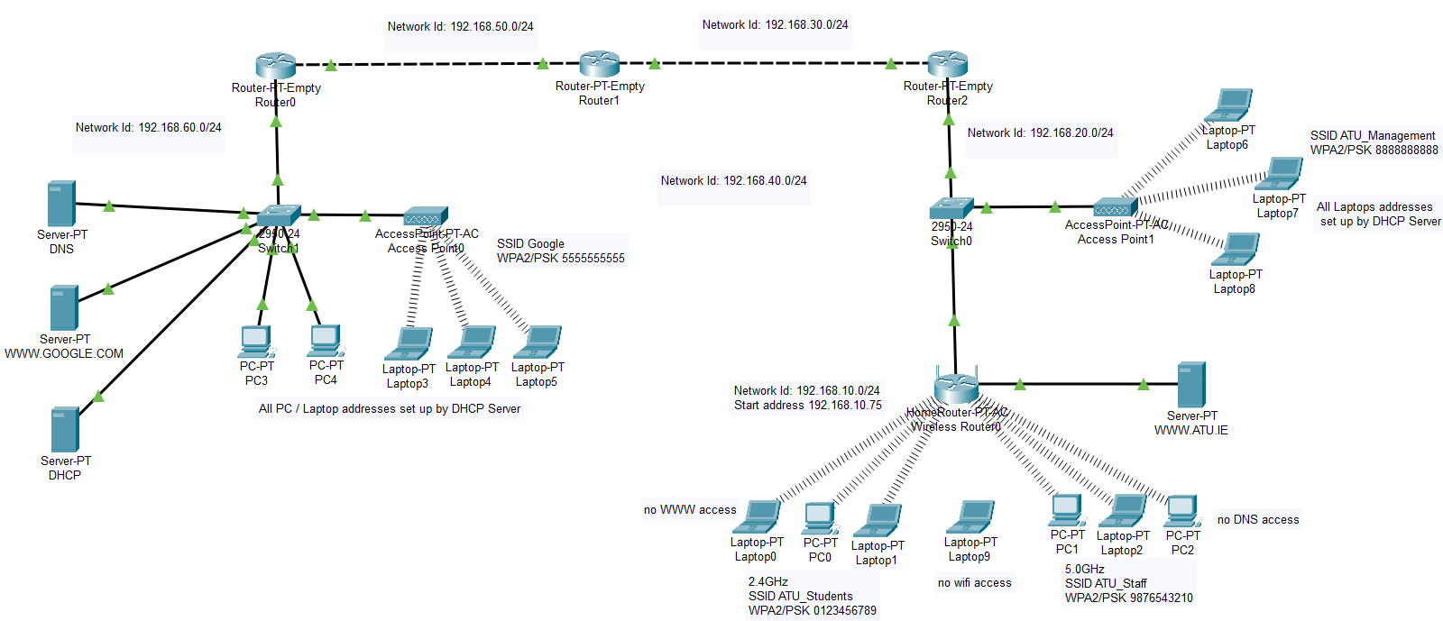

Your assessment today is to implement the above network. Network addresses, SSID’s, PSK’s, Start Addresses, Servers are included in the diagram.

All devices associating with the wireless router get their addresses from the wireless router. All other PC’s/Laptops get their address from the DHCP Server. Apart from access restrictions devices, all devices should be able to access both WWW Servers using their URL. Notice the Access Restrictions on PC2 and Laptop9.

The following line of CLI code may prove useful to you:
Enable
Configure Terminal
Interface FastEthernet0/0
IP Helper-Address 192.168.?.?
Exit
Exit
Exit

File should be saved as Lan**.pkt where ** indicates your initials.

SAVE YOUR FILE REGULARILY
INCLUDE YOUR NAME IN A LABEL AT THE TOP OF THE FILE.
PLEASE DO NOT ZIP THE FILE BEFORE YOU UPLOAD IT.

At the end of the assessment, please upload your file to Moodle.

Best of luck!!

